**Higher Diploma in Computing – Part-Time 2014**

**Semester 3**

**Course Module: Software Engineering for Web Applications**

**(**HDC-SEWA)

**Main Assignment – Description / Research Documentation**

**Student Names: Gavin McGovern, Frank Deasy, Cathal Mulkere**

**Student ID Nos.: 2862213, 2864260, 2859287**

**Lecturer: Mark Scanlon**

**Date Due: 05-01-2015**

Introduction

GFC-Stats.com is happy to present the first version of a new dynamic website with a lot of potential. Having reviewed current offerings on the web in relation to statistics available on various sports a perceived gap exists in the market for a site targeted at sportspeople on which they can record and compare their performance in both training and matches against their peers and competitors.

An interactive website prototype has been developed initially designed for GAA football players but with scope to translate to other sports. Users are able to record data relating to their daily training and match activities under a number of criteria onto a database that will allow them compare key aspects of their training and performances against others in their field. This comparison will be displayed by way of graphs and tables making it clear where more effort is needed and where they compare favourably to their competition.

*Note: Initial data utilised for comparison purposes is partly fictitious and used for the purposes of the draft design.*

Design Layout

Our understanding on the design layout is that we are to develop the site using HTML, PHP, CSS, Java Script and MySQL. Thus tools such a Bootstrap and JQUERY as well as more formalised functions have not been used in site design or development. These limitations refined certain aspirations we had on the functionality of the site and how we would like it to present. Thus while researching the design options we found that the majority of the more popular sites tend to create a customised format though shades of grey appear to be more popular for physical training sites. In an effort to keep the site crisp and clear we decided to use these base-colour attributes on our site.

For the prototype we have included 4 key pages.

1. A Home page which explains the reason for and benefits of the site.
2. An About us page which explains the details of the project in question, the people behind it and also explains how the site works for interested users and the likely outcomes they can achieve along with a resource library that they can access tips through various media.
3. Contact us page gives details of how to make contact with us through the various media and a location map of where to find us. We have also included and enquiry form here where users can submit specific enquires via email.
4. Profile - Analysis pages, where the user can actually start to interact with the site and review their data. To do this they must first register and login into the system.

Registration

This is a short form that each user must fill out which includes details to input for their profile. Once registered, the data inputted is recorded in our supporting database and they can then login to enter the Analysis section and begin to use the site.

Profile - Analysis

The user can input their training data for each session (be it with their Club, County, or on a Personal basis) and their match data for each match played (again be it with their Club, County, etc.). Once they have done this they will be able to compare their performance against the data per other players in the database. Ideally we would like this analysis to develop further to capture more information but initially we wanted to keep the time needed inputting data to a minimum so kept the forms short yet useful. Creating future links to download data from some of the tools available on the market would allow greater input and more relevant results. This was not considered as core functionality at this time.

Assumptions

We initially populated the database with player data from a number of inter-county players to create a base from which to compare inputs. Although the specific data isn’t accurate it correlates with the targets and schedules of best practice in the sport.

We have researched current thinking on best practice for training and performance measurement and would ultimately aim to link with some of the multiple software input devices like dartfish. Targets and online training / coaching would be an avenue we believe could be explored using expert analysis and coaches on a consultancy basis.

Site Map Diagram:

Below is a breakdown of the site map.

Registration

HOME PAGE

Contact us

About us

Login

Registration

Profile

Training History

Profile Update

Match History

The flow of the site allows users to navigate from the Home page to the About us and Contact us pages. From these pages the user can go directly to any of the other pages including the Login or Registration pages. Once logged in the user has access to the profile analysis page. From this page the user can link see information on the Training and Match history and can update their profile. On logging out they will return to the Home page.

Wireframe Diagram:

Home Page

The home page is the main landing page and its initial view will be of rotating images in the centre with a twitter feed to the right and a navigation bar to the left to offer optical balance. The menu bar on the top will be standard across all main pages

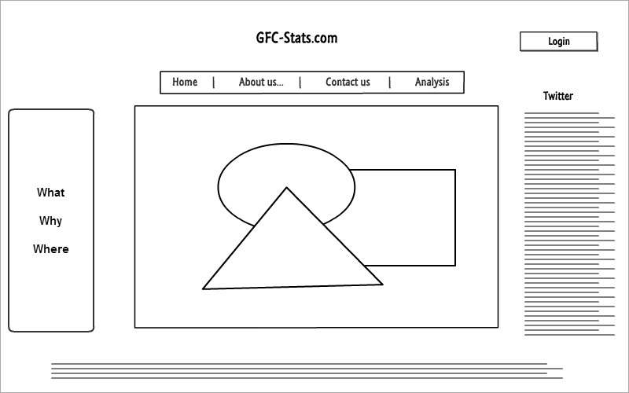

About us

The about us page is primarily an information source for users and offers details on the site how it works and some resources related to the topic for download or viewing on video

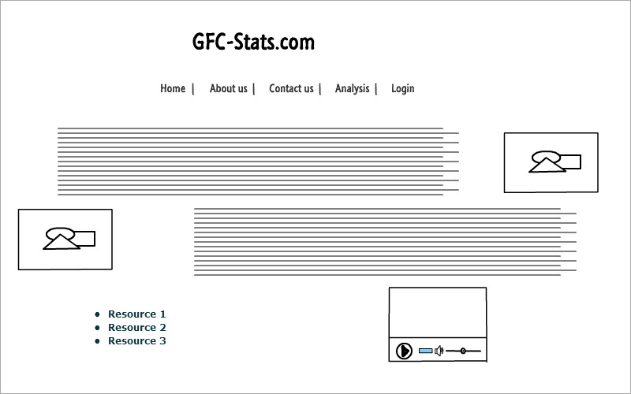

Contact us

The contatct us page is primarily an information source for users and offers details on the site how it works and some resources related to the topic for download or viewing on video

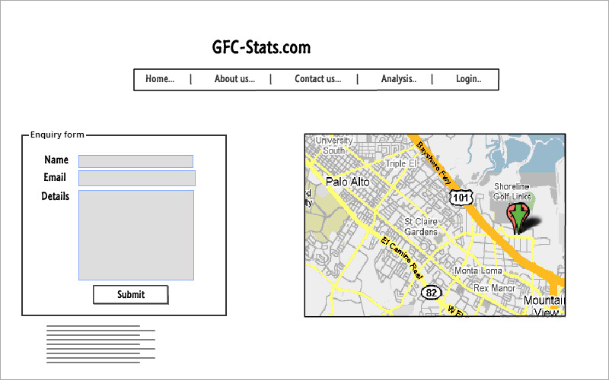

Profile - Analysis Page

This is the first real interaction page for the user where details will be input and feedback received. The user will fill one or both forms in the middle of the page and click a button to generate graphs and tables specific to their input.

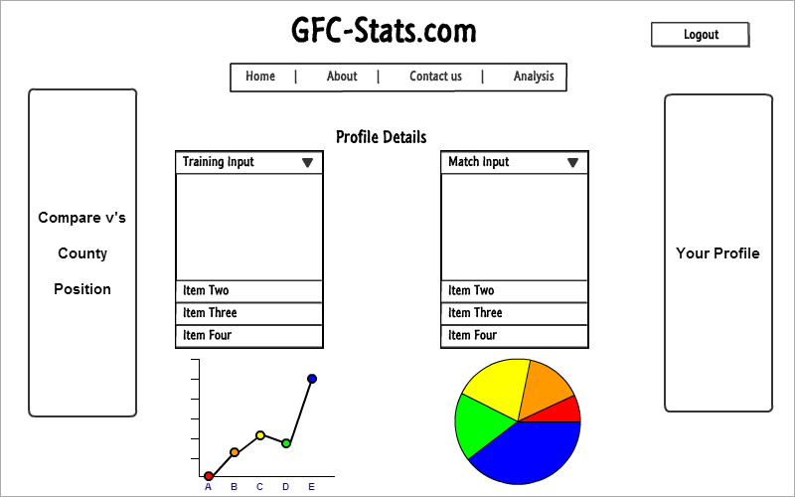

**Research Sites**

As part of the design and development of the Site concept, review and consideration were given to a number of similar sites currently on the Internet. The design implementations were therefore based on the functionality, CSS style, colour-schemes and access restrictions of a number of common and little know websites. In particular, the following sites should be noted:

* [www.jscharts.com/](http://www.jscharts.com/) – JS Charts functionality used in the Site
* [www.wikipedia.org](http://www.wikipedia.org) – used for Data input and Profile-Analysis Design
* <http://www.anatomyat1220.com/>
* <http://gaelicstats.com/>
* <http://www.sportplan.net/>
* <http://tocasports.com/>
* <http://www.statscool.com/>
* <https://dontfoul.wordpress.com/>
* [www.w3schools.com](http://www.w3schools.com) – used for CSS and Form functionality
* <https://developers.google.com/maps> – Google Maps API used in the Site

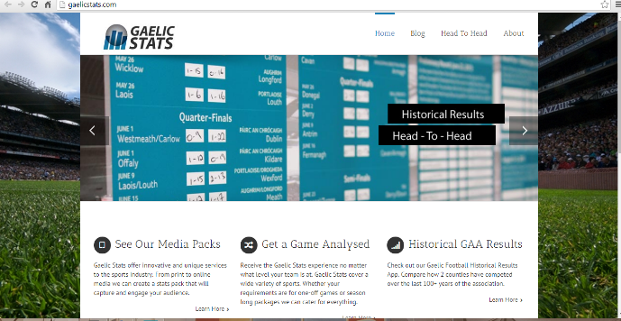

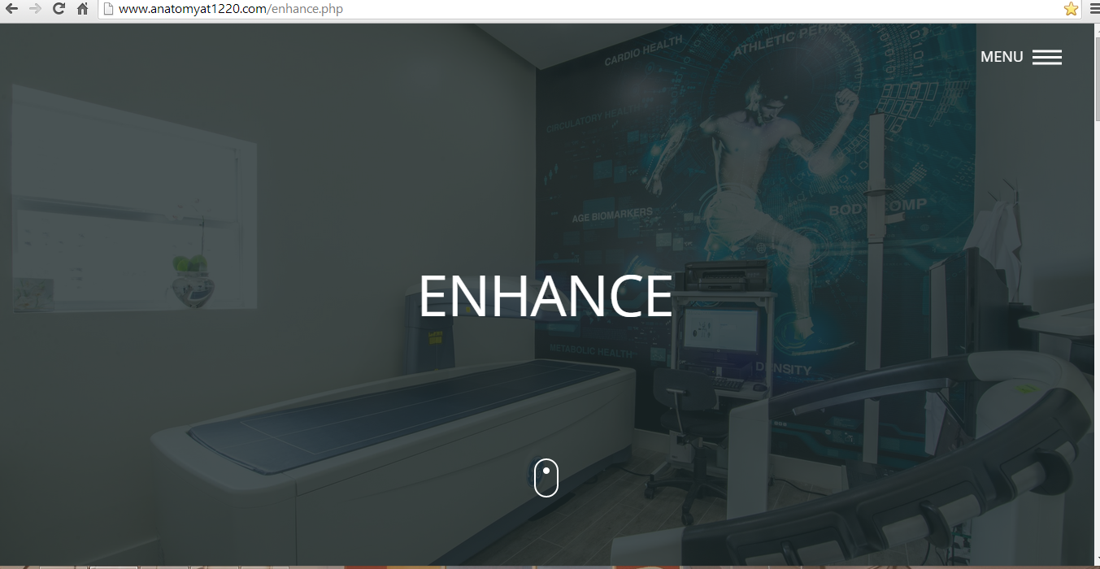

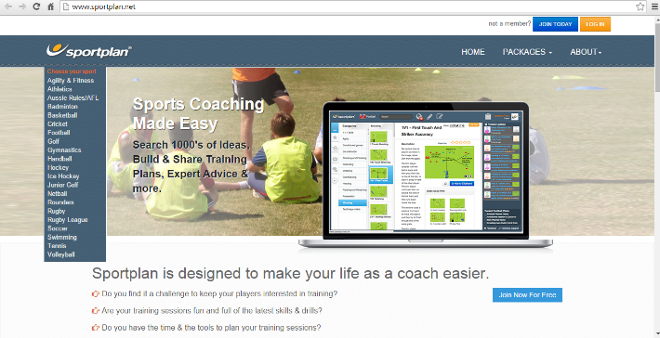 

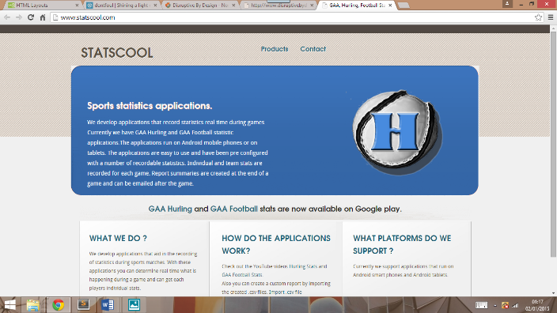 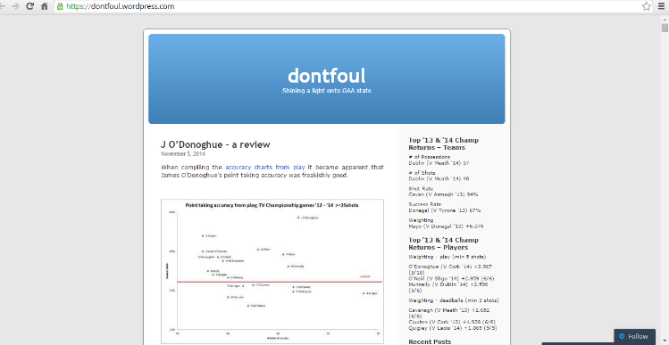

ER Diagram – Tables and Format

Tables and Attributes:

Based on the final design of the Database the following attributes have been included in the associated Entity Tables:

|  |  |  |
| --- | --- | --- |
| **Entity** |  |  |
| Users | **Username[PK]**  Password | Name  User Email Address |
| Teams | **Name[PK]**  Level (i.e. club, county etc.)  County (if a Club Team) | Province (if a Club or County Team)  Manager  County Grounds |
| Players | **Name [PK]**  DOB  Gender  Height(in meters) | Club  County  Position |
| Matches | Team A  Team B  Team A Goals  Team A Points  Team B Goals  **(Team A, Team B, Date [PK])** | Team B Points  Type  Date  Length(in minutes)  Venue |
| Training | Player Name  Date  Status (i.e. if injured)  Type (i.e. club, personal, county, etc.)  **(Player Name, Type, Date [PK])** | Skills Minutes  Fitness Minutes  Gym Minutes  Recovery Minutes |
| Match Performance | Player-Name  Match-Date  Match-Type  Minutes Played  Distance Covered (in meters)  Number of Possessions  Number of Possessions in Scoring Zone  Possessions Won By Clean Catches  Possessions Won By Tackles / Turnovers  Passes Complete  Hand Passes Completed  Foot Passes Completed  Passes Incomplete  Attempts (i.e. shots at goal)  **(Player-Name, Match-Date, Team [PK])** | Shots On Target  Shots Wide  Saves  Goals  Points  Points From Frees  Tackles Made  Frees For  Frees Against  Attacking Runs  Defensive Runs  Red Card  Yellow Card  Black Card |

ER Diagram:

